# Chapter 6: CONFIGURATION MANAGEMENT

Configuration management system used to keep track of an organization’s hardware, software and other information. It is pre-plan to secure the system of any project.

It include the software versions in certain period, updating them and maintaining. It may also called configuration control. Its focuses on the beginning and keeping consistency of a product’s performance and its functional information. Finally, at the end of project session, a full version of the project is released and given over to the owner.It also includes backup feature and provides coordination in project development.

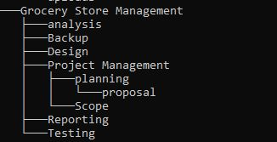

Figure 9 Configuration Management

As shown in the above figure the configuration management of this project Grocery store management system done The main directory of the project is ‘Grocery store management’ and its sub-directories are Analysis, Backup, Design, Project Management, reporting and Testing. Another sub-directory made in Project Management; Planning and Scope where the proposal lies in planning directory as named ‘00175005_aanchalshrestha_Proposal.docx. We will used GitHub as our backup of our project <https://github.com/aanch102/>.